Sam- below is what danny, vicky and I did for our last project. Basically some diagrams of the structure, security measures, devops, screen shots of any testing etc. text to explain the parts you made and the technologies used.
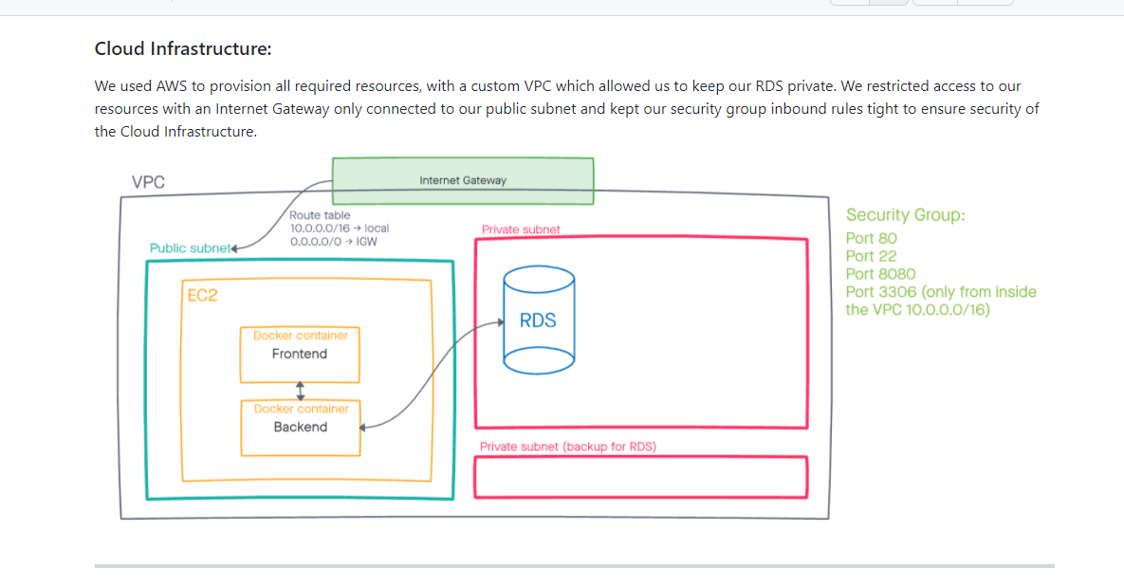
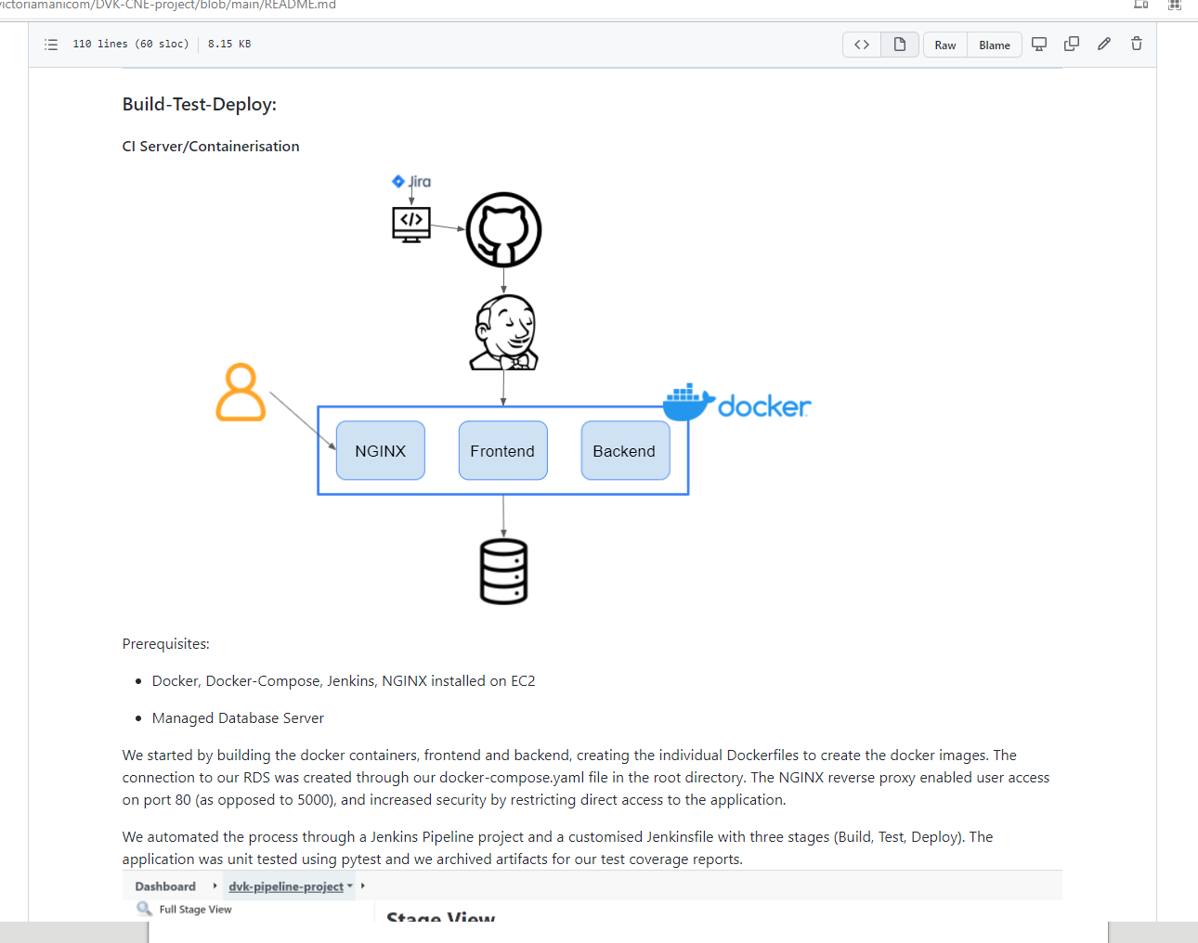

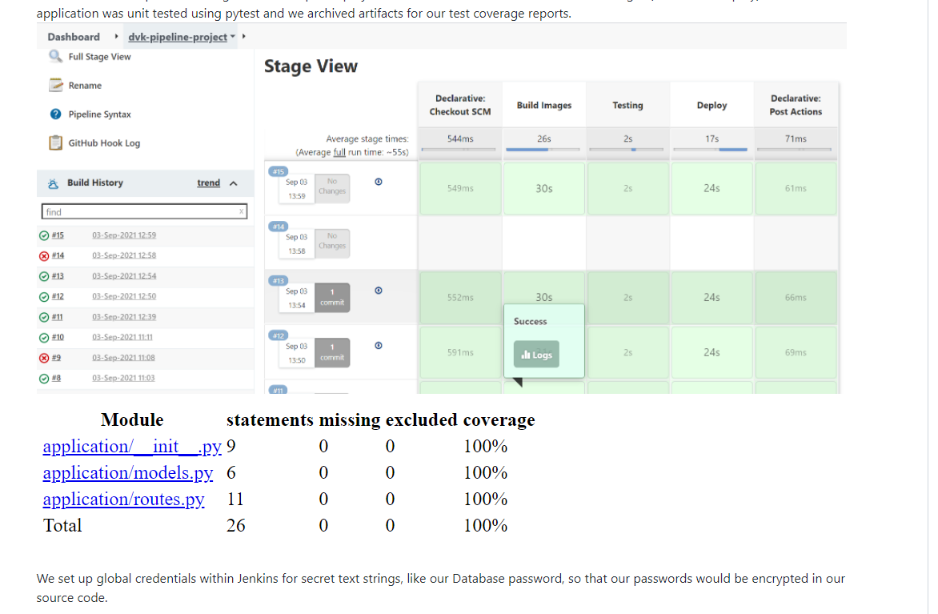
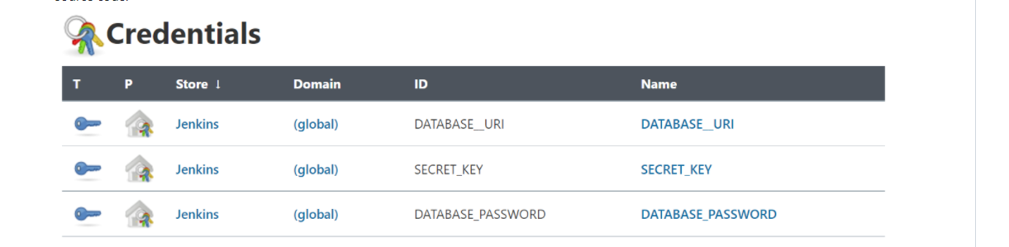
Daryl & Ryan – something similar for the front end (Basically some diagrams of the structure, security measures, testing, screen shots of any etc.

